## What is an API?

APIs are mechanisms that enable two software components to communicate with each other using a set of definitions and protocols. For example, the weather bureau’s software system contains daily weather data. The weather app on your phone “talks” to this system via APIs and shows you daily weather updates on your phone.

## What does API stand for?

API stands for Application Programming Interface. In the context of APIs, the word Application refers to any software with a distinct function. Interface can be thought of as a contract of service between two applications. This contract defines how the two communicate with each other using requests and responses. Their API documentation contains information on how developers are to structure those requests and responses.

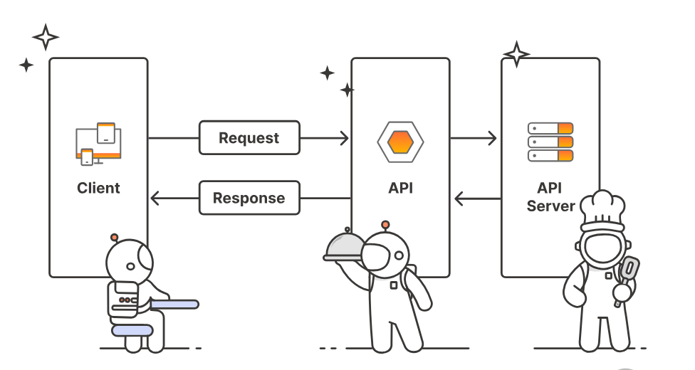

## 

## **What is JSON?**

**JSON** stands for **JavaScript Object Notation**. It is a lightweight data-interchange format that is easy for humans to read and write, and easy for machines to parse and generate.

### **JSON Example:**

{

"name": "John Doe",

"age": 30,

"email": "john.doe@example.com",

"isActive": true

}

In this example, the data is represented as key-value pairs. JSON supports basic data types like:

* Strings
* Numbers
* Booleans
* Arrays
* Objects

## **Advantages of Using JSON**

1. **Lightweight** JSON is less verbose than other formats like XML, which means faster transmission and lower bandwidth usage.
2. **Human-readable** The format is easy to read and write, even for non-programmers, making debugging and documentation simpler.
3. **Easy to Parse** Most modern programming languages (JavaScript, Python, Java, C#, etc.) have built-in libraries for parsing JSON.
4. **Widely Supported** JSON is a standard in web development and is supported across platforms, devices, and languages.
5. **Works Well with REST APIs** JSON pairs naturally with RESTful APIs, making it a common choice for data exchange in web and mobile applications.
6. **Flexible and Scalable** JSON structures can be nested and extended easily, making them suitable for representing complex data.